TODO Application

Functional requirements

1. Add a new task to the to-do list
2. View all tasks from the to-do list
3. Delete a task from the to-do list
4. Change the task’s status from pending to started, completed, or late
5. View how many tasks are either pending, started, completed, or late
6. Tasks on the to-do list will still be there after the application is restarted

Nonfunctional requirements

1. A new task added to the list will be saved via database in mysql server
2. The database will contain a table for each task status (pending, started, completed, late)
3. Database queries will be made using php
4. Changing a task’s status will be done by moving a task ID to the designated table that corresponds with a user’s status request
5. Application will launch via Windows batch file
6. Viewing all tasks from the to-do list will be completed by creating a join of all 4 tables

System architecture diagram

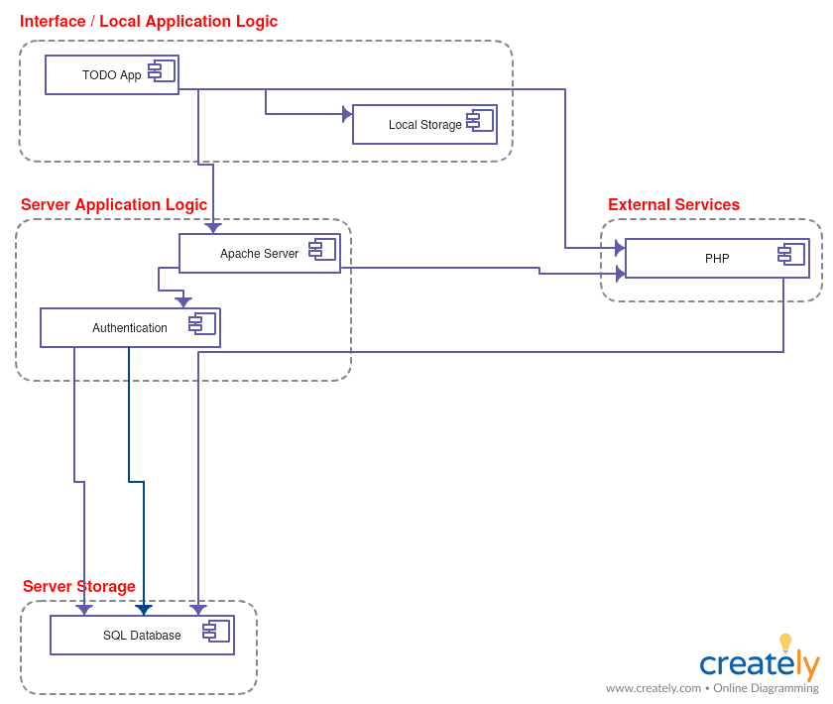

Data flow diagram (level 2)

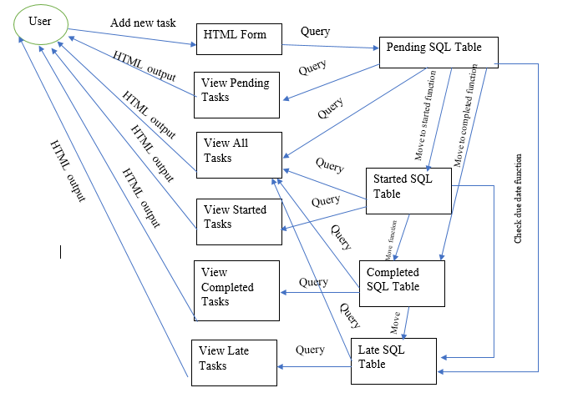

Use cases

|  |  |  |  |
| --- | --- | --- | --- |
| Use Case ID | Use Case | Primary Actor | Priority |
| 1 | Add new task | User | Med |
| 2 | View all tasks | User | Med |
| 3 | Delete a task | User | Med |
| 4 | Mark task as started | User | Med |
| 5 | Mark task as completed | User | Med |
| 6 | View pending tasks | User | Med |

Sequence Diagrams

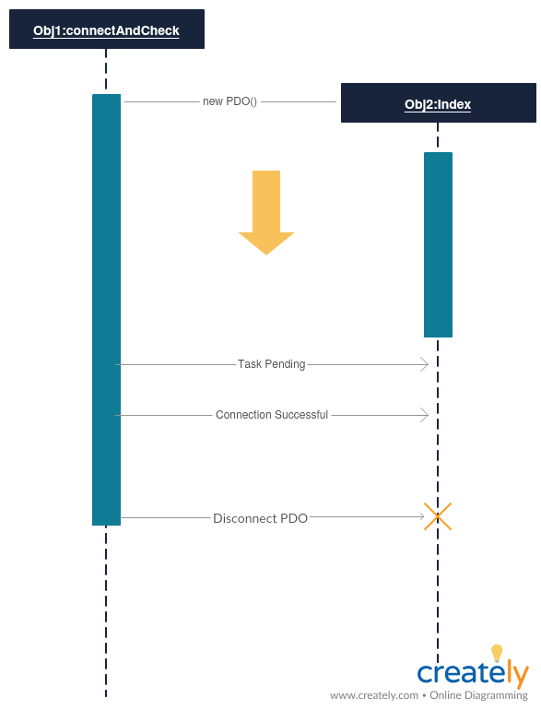

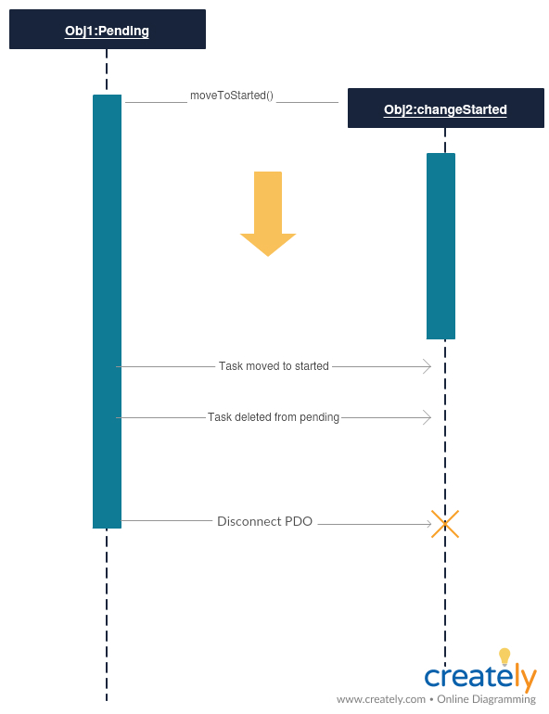

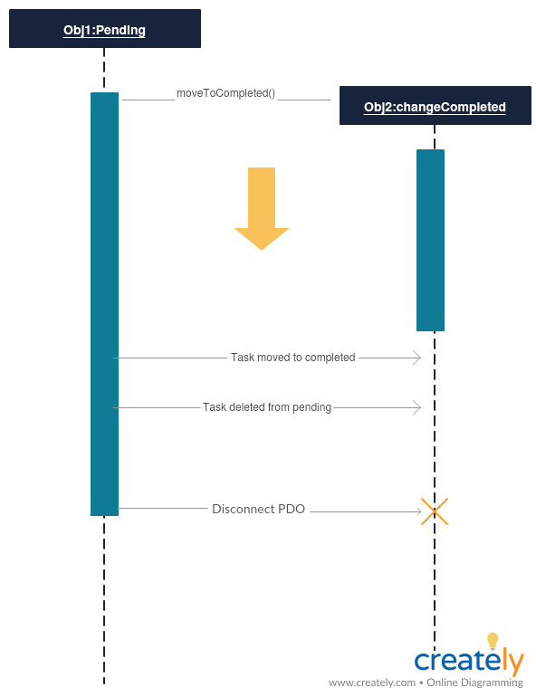

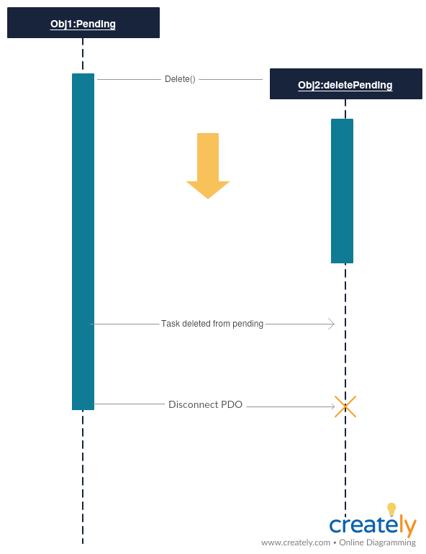

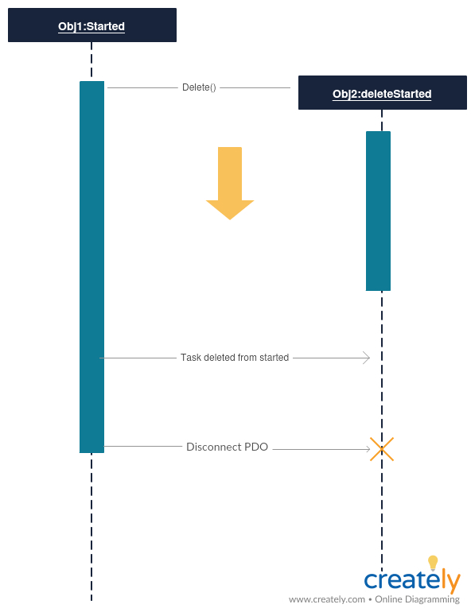

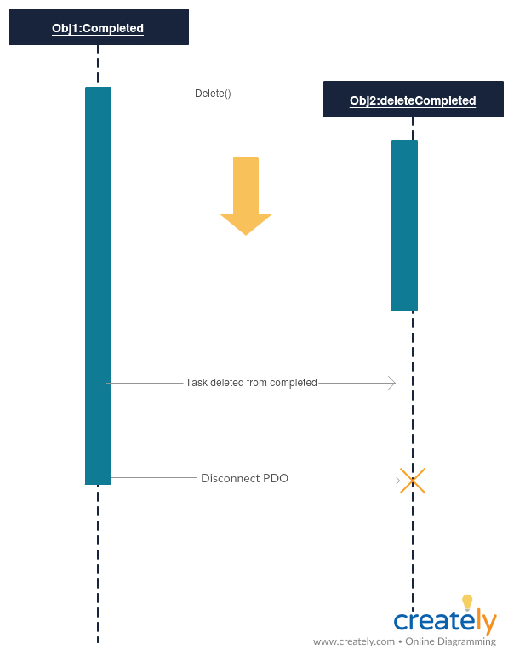

Database design

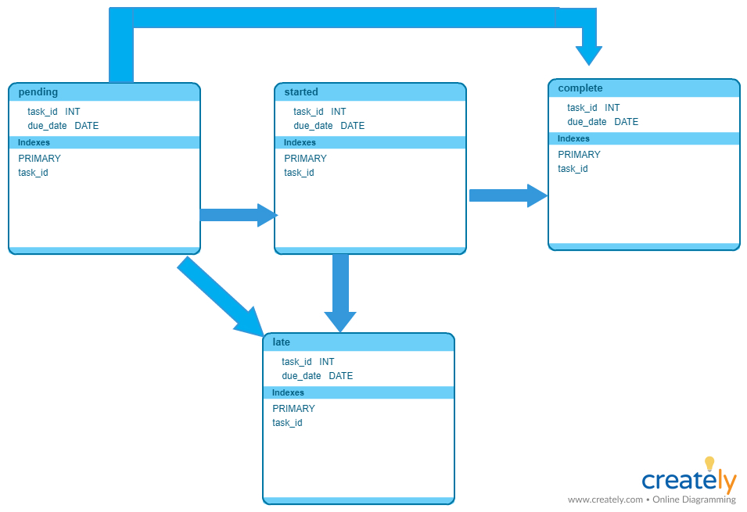

Class diagram

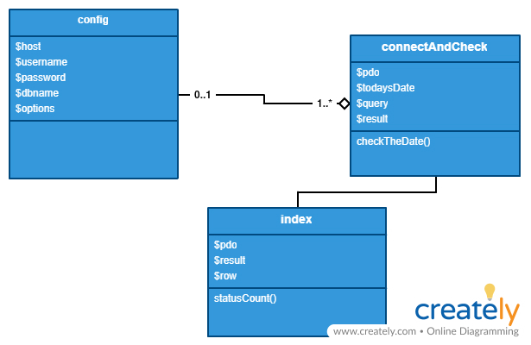

Test cases

|  |  |  |  |
| --- | --- | --- | --- |
| Test | Description | Steps | Expected Result |
| Add a task | A task should be able to be added to the system. Precondition: Date is filled out in correct format | 1. Open index.php 2. Select “add task” 3. Fill out form 4. Click “submit” | When navigating back to index.php, there should be 1 more pending task than there was before. |
| View all tasks | All tasks should be able to be viewed, regardless of status. Precondition: There is at least one task added to system. | 1. Open index.php 2. Select “view all tasks | If a task has already been added to the system, there should be that task and whatever previous added tasks viewable in all.php. |
| Change task status to started | A task should be able to be changed from pending to started. Precondition: There is at least one pending task added to system. | 1. Open index.php 2. Select “pending” 3. Select “mark as started” next to task item 4. Go back to index.php | There should be 1 more started task in index.php than there was before. |
| Change task status to completed | A task should be able to be changed from pending, started, or late to started. Precondition: There is at least one pending, started or late task added to system. | 1. Open index.php 2. Select “pending”, “started”, or “late” 3. Select “mark as started” next to task item 4. Go back to index.php | There should be 1 more started task in index.php than there was before. |
| Delete task | A task should be able to be deleted from pending, started, completed or late to started. Precondition: There is at least one pending, started, completed or late task added to system. | 1. Open index.php 2. Select “pending”, “started”, “completed” or “late” 3. Select “delete” next to task item 4. Go back to index.php 5. Select “view all” | The task that was chosen to be deleted should not be there. |
| View tasks error check | System should not crash when selecting to view a task when there are none available. Precondition: No tasks are in the field chosen. | 1. Open index.php 2. Select “pending”, “started”, “completed” or “late” | The screen should output “no tasks.” |